Chapter 04
Long-Term Financial Planning and Growth

Multiple Choice Questions
1. Phil is working on a financial plan for the next three years. This time period is referred to as which one of the following?
A. financial range
B. planning horizon
C. planning agenda
D. short-run
E. current financing period

2. Atlas Industries combines the smaller investment proposals from each operational unit into a single project for planning purposes. This process is referred to as which one of the following?
A. conjoining
B. aggregation
C. conglomeration
D. appropriation
E. summation

3. Which one of the following terms is applied to the financial planning method which uses the projected sales level as the basis for determining changes in balance sheet and income statement account values?
A. percentage of sales method
B. sales dilution method
C. sales reconciliation method
D. common-size method
E. trend method

4. Which one of the following terms is defined as dividends paid expressed as a percentage of net income?
A. dividend retention ratio
B. dividend yield
C. dividend payout ratio
D. dividend portion
E. dividend section

5. Which one of the following correctly defines the retention ratio?
A. one plus the dividend payout ratio
B. addition to retained earnings divided by net income
C. addition to retained earnings divided by dividends paid
D. net income minus additions to retained earnings
E. net income minus cash dividends

6. Which one of the following ratios identifies the amount of assets a firm needs in order to generate $1 in sales?
A. current ratio
B. equity multiplier
C. retention ratio
D. capital intensity ratio
E. payout ratio

7. The internal growth rate of a firm is best described as the:
A. minimum growth rate achievable assuming a 100 percent retention ratio.
B. minimum growth rate achievable if the firm maintains a constant equity multiplier.
C. maximum growth rate achievable excluding external financing of any kind.
D. maximum growth rate achievable excluding any external equity financing while maintaining a constant debt-equity ratio.
E. maximum growth rate achievable with unlimited debt financing.

8. The sustainable growth rate of a firm is best described as the:
A. minimum growth rate achievable assuming a 100 percent retention ratio.
B. minimum growth rate achievable if the firm maintains a constant equity multiplier.
C. maximum growth rate achievable excluding external financing of any kind.
D. maximum growth rate achievable excluding any external equity financing while maintaining a constant debt-equity ratio.
E. maximum growth rate achievable with unlimited debt financing.

9. You are developing a financial plan for a corporation. Which of the following questions will be considered as you develop this plan?
I. How much net working capital will be needed?
II. Will additional fixed assets be required?
III. Will dividends be paid to shareholders?
IV. How much new debt must be obtained?
A. I and IV only
B. II and III only
C. I, III, and IV only
D. II, III, and IV only
E. I, II, III, and IV

10. Financial planning:
A. focuses solely on the short-term outlook for a firm.
B. is a process that firms employ only when major changes to a firm's operations are anticipated.
C. is a process that firms undergo once every five years.
D. considers multiple options and scenarios for the next two to five years.
E. provides minimal benefits for firms that are highly responsive to economic changes.

11. Financial planning accomplishes which of the following for a firm?
I. determination of asset requirements
II. development of plans to contend with unexpected events
III. establishment of priorities
IV. analysis of funding options
A. I and III only
B. II and IV only
C. I, III, and IV only
D. I, II, and III only
E. I, II, III, and IV

12. Which of the following questions are appropriate to address during the financial planning process?
I. Should the firm merge with a competitor?
II. Should additional shares of stock be sold?
III. Should a particular division be sold?
IV. Should a new product be introduced?
A. I, II, and III only
B. I, II, and IV only
C. I, III, and IV only
D. II, III, and IV only
E. I, II, III, and IV

13. Which one of the following statements concerning financial planning for a firm is correct?
A. Financial planning for fixed assets is done on a segregated basis within each division.
B. Financial plans often contain alternative options based on economic developments.
C. Financial plans frequently contain conflicting goals.
D. Financial plans assume that firms obtain no additional external financing.
E. The financial planning process is based on a single set of economic assumptions.

14. You are getting ready to prepare pro forma statements for your business. Which one of the following are you most apt to estimate first as you begin this process?
A. fixed assets
B. current expenses
C. sales forecast
D. projected net income
E. external financing need

15. Which one of the following statements is correct?
A. Pro forma statements must assume that no new equity is issued.
B. Pro forma statements are projections, not guarantees.
C. Pro forma statements are limited to a balance sheet and income statement.
D. Pro forma financial statements must assume that no dividends will be paid.
E. Net working capital needs are excluded from pro forma computations.

16. When utilizing the percentage of sales approach, managers:
I. estimate company sales based on a desired level of net income and the current profit margin.
II. consider only those assets that vary directly with sales.
III. consider the current production capacity level.
IV. can project both net income and net cash flows.
A. I and II only
B. II and III only
C. III and IV only
D. I, III, and IV only
E. II, III, and IV only

17. Which one of the following is correct in relation to pro forma statements?
A. Fixed assets must increase if sales are projected to increase.
B. Net working capital is affected only when a firm's sales are expected to exceed the firm's current production capacity.
C. The addition to retained earnings is equal to net income plus dividends paid.
D. Long-term debt varies directly with sales when a firm is currently operating at maximum capacity.
E. Inventory changes are directly proportional to sales changes.

18. When constructing a pro forma statement, net working capital generally:
A. remains fixed.
B. varies only if the firm is currently producing at full capacity.
C. varies only if the firm maintains a fixed debt-equity ratio.
D. varies only if the firm is producing at less than full capacity.
E. varies proportionally with sales.

19. A pro forma statement indicates that both sales and fixed assets are projected to increase by 7 percent over their current levels. Given this, you can safely assume that the firm:
A. is projected to grow at the internal rate of growth.
B. is projected to grow at the sustainable rate of growth.
C. currently has excess capacity.
D. is currently operating at full capacity.
E. retains all of its net income.

20. A firm is currently operating at full capacity. Net working capital, costs, and all assets vary directly with sales. The firm does not wish to obtain any additional equity financing. The dividend payout ratio is constant at 40 percent. If the firm has a positive external financing need, that need will be met by:
A. accounts payable.
B. long-term debt.
C. fixed assets.
D. retained earnings.
E. common stock.

21. Which one of the following policies most directly affects the projection of the retained earnings balance to be used on a pro forma statement?
A. net working capital policy
B. capital structure policy
C. dividend policy
D. capital budgeting policy
E. capacity utilization policy

22. You are comparing the current income statement of a firm to the pro forma income statement for next year. The pro forma is based on a four percent increase in sales. The firm is currently operating at 85 percent of capacity. Net working capital and all costs vary directly with sales. The tax rate and the dividend payout ratio are fixed. Given this information, which one of the following statements must be true?
A. The projected net income is equal to the current year's net income.
B. The tax rate will increase at the same rate as sales.
C. Retained earnings will increase by four percent over its current level.
D. Total assets will increase by less than four percent.
E. Total liabilities and owners' equity will increase by four percent.

23. A firm is operating at 90 percent of capacity. This information is primarily needed to project which one of the following account values when compiling pro forma statements?
A. sales
B. costs of goods sold
C. accounts receivable
D. fixed assets
E. long-term debt

24. Which one of the following capital intensity ratios indicates the largest need for fixed assets per dollar of sales?
A. 0.70
B. 0.86
C. 1.00
D. 1.06
E. 1.15

25. Which of the following are needed to determine the amount of fixed assets required to support each dollar of sales?
I. current amount of fixed assets
II. current sales
III. current level of operating capacity
IV. projected growth rate of sales
A. I and III only
B. II and IV only
C. I, II, and III only
D. II, III, and IV only
E. I, II, III, and IV

26. The plowback ratio is:
A. equal to net income divided by the change in total equity.
B. the percentage of net income available to the firm to fund future growth.
C. equal to one minus the retention ratio.
D. the change in retained earnings divided by the dividends paid.
E. the dollar increase in net income divided by the dollar increase in sales.

27. A firm's net working capital and all of its expenses vary directly with sales. The firm is operating currently at 96 percent of capacity. The firm wants no additional external financing of any kind. Which one of the following statements related to the firm's pro forma statements for next year must be correct?
A. Total liabilities will remain constant at this year's value.
B. The maximum rate of sales increase is 4 percent.
C. The firm cannot exceed its internal rate of growth.
D. The projected owners' equity will equal this year's ending equity balance.
E. Fixed assets must remain constant at the current level.

28. Which one of the following will increase the maximum rate of growth a corporation can achieve?
A. avoidance of external equity financing
B. increase in corporate tax rates
C. reduction in the retention ratio
D. decrease in the dividend payout ratio
E. decrease in sales given a positive profit margin

29. Martin Aerospace is currently operating at full capacity based on its current level of assets. Sales are expected to increase by 4.5 percent next year, which is the firm's internal rate of growth. Net working capital and operating costs are expected to increase directly with sales. The interest expense will remain constant at its current level. The tax rate and the dividend payout ratio will be held constant. Current and projected net income is positive. Which one of the following statements is correct regarding the pro forma statement for next year?
A. The pro forma profit margin is equal to the current profit margin.
B. Retained earnings will increase at the same rate as sales.
C. Total assets will increase at the same rate as sales.
D. Long-term debt will increase in direct relation to sales.
E. Owners' equity will remain constant.

30. A firm's external financing need is financed by which of the following?
A. retained earnings
B. net working capital and retained earnings
C. net income and retained earnings
D. debt or equity
E. owners' equity, including retained earnings

31. Sales can often increase without increasing which one of the following?
A. accounts receivable
B. cost of goods sold
C. accounts payable
D. fixed assets
E. inventory

32. Blasco Industries is currently at full-capacity sales. Which one of the following is limiting sales to this level?
A. net working capital
B. long-term debt
C. inventory
D. fixed assets
E. debt-equity ratio

33. All else constant, which one of the following will increase the internal rate of growth?
A. decrease in the retention ratio
B. decrease in net income
C. increase in the dividend payout ratio
D. decrease in total assets
E. increase in costs of goods sold

34. The external financing need:
A. will limit growth if unfunded.
B. is unaffected by the dividend payout ratio.
C. must be funded by long-term debt.
D. ignores any changes in retained earnings.
E. considers only the required increase in fixed assets.

35. Which one of the following will cause the sustainable growth rate to equal to internal growth rate?
A. dividend payout ratio greater than 1.0
B. debt-equity ratio of 1.0
C. retention ratio between 0.0 and 1.0
D. equity multiplier of 1.0
E. zero dividend payments

36. The sustainable growth rate:
A. assumes there is no external financing of any kind.
B. assumes no additional long-term debt is available.
C. assumes the debt-equity ratio is constant.
D. assumes the debt-equity ratio is 1.0.
E. assumes all income is retained by the firm.

37. If a firm equates its pro forma sales growth to the rate of sustainable growth, and has positive net income and excess capacity, then the:
A. maximum capacity level will have to increase at the same rate as sales growth.
B. total assets will have to increase at the same rate as sales growth.
C. debt-equity ratio will increase.
D. retained earnings will increase.
E. number of common shares outstanding will increase.

38. Sal's Pizza has a dividend payout ratio of 10 percent. The firm does not want to issue additional equity shares but does want to maintain its current debt-equity ratio and its current dividend policy. The firm is profitable. Which one of the following defines the maximum rate at which this firm can grow?
A. internal growth rate × (1 - 0.10)
B. sustainable growth rate × (1 - 0.10)
C. internal growth rate
D. sustainable growth rate
E. zero percent

39. Which of the following can affect a firm's sustainable rate of growth?
I. capital intensity ratio
II. profit margin
III. dividend policy
IV. debt-equity ratio
A. III only
B. I and III only
C. II, III, and IV only
D. I, II, and IV only
E. I, II, III, and IV

40. Financial plans generally tend to ignore which one of the following?
A. dividend policy
B. manager's goals and objectives
C. risks associated with cash flows
D. operating capacity levels
E. capital structure policy

41. The financial planning process tends to place the least emphasis on which one of the following?
A. growth limitations
B. capacity utilization
C. market value of a firm
D. capital structure of a firm
E. dividend policy

42. The financial planning process:
I. involves internal negotiations among divisions.
II. quantifies senior manager's goals.
III. considers only internal factors.
IV. reconciles company activities across divisions.
A. III and IV only
B. II and III only
C. I, II, and IV only
D. II, III, and IV only
E. I, II, III, and IV

43. A Procrustes approach to financial planning is based on:
A. a policy of producing a financial plan once every five years.
B. developing a plan around the goals of senior managers.
C. a proactive approach to the economic outlook.
D. a flexible capital budget.
E. a flexible capital structure.

44. Fresno Salads has current sales of $4,900 and a profit margin of 6.5 percent. The firm estimates that sales will increase by 5 percent next year and that all costs will vary in direct relationship to sales. What is the pro forma net income?
A. $303.33
B. $327.18
C. $334.43
D. $338.70
E. $341.10

45. Wagner Industrial Motors, which is currently operating at full capacity, has sales of $29,000, current assets of $1,600, current liabilities of $1,200, net fixed assets of $27,500, and a 5 percent profit margin. The firm has no long-term debt and does not plan on acquiring any. The firm does not pay any dividends. Sales are expected to increase by 4.5 percent next year. If all assets, short-term liabilities, and costs vary directly with sales, how much additional equity financing is required for next year?
A. -$259.75
B. -$201.19
C. $967.30
D. $1,099.08
E. $1,515.25

46. The Cookie Shoppe expects sales of $437,500 next year. The profit margin is 4.8 percent and the firm has a 30 percent dividend payout ratio. What is the projected increase in retained earnings?
A. $14,700
B. $17,500
C. $18,300
D. $20,600
E. $21,000

47. Gladsden Refinishers currently has $21,900 in sales and is operating at 45 percent of the firm's capacity. What is the full capacity level of sales?
A. $31,755
B. $36,250
C. $48,667
D. $51,333
E. $54,500

48. The Corner Store has $219,000 of sales and $187,000 of total assets. The firm is operating at 87 percent of capacity. What is the capital intensity ratio at full capacity?
A. 0.62
B. 0.68
C. 0.74
D. 1.35
E. 1.47

49. Miller Bros. Hardware is operating at full capacity with a sales level of $689,700 and fixed assets of $468,000. The profit margin is 7 percent. What is the required addition to fixed assets if sales are to increase by 10 percent?
A. $3,276
B. $4,680
C. $28,400
D. $32,760
E. $46,800

50. Designer's Outlet has a capital intensity ratio of 0.87 at full capacity. Currently, total assets are $48,900 and current sales are $52,300. At what level of capacity is the firm currently operating?
A. 89 percent
B. 91 percent
C. 93 percent
D. 96 percent
E. 98 percent

51. Monika's Dinor is operating at 94 percent of its fixed asset capacity and has current sales of $611,000. How much can the firm grow before any new fixed assets are needed?
A. 4.99 percent
B. 5.78 percent
C. 6.02 percent
D. 6.38 percent
E. 6.79 percent

52. Stop and Go has a 4.5 percent profit margin and a 15 percent dividend payout ratio. The total asset turnover is 1.6 and the debt-equity ratio is 0.60. What is the sustainable rate of growth?
A. 9.13 percent
B. 9.54 percent
C. 9.89 percent
D. 10.26 percent
E. 10.85 percent

53. R. N. C., Inc. desires a sustainable growth rate of 4.5 percent while maintaining a 40 percent dividend payout ratio and a 6 percent profit margin. The company has a capital intensity ratio of 1.23. What equity multiplier is required to achieve the company's desired rate of growth?
A. 1.33
B. 1.38
C. 1.42
D. 1.47
E. 1.53

54. A firm has a retention ratio of 45 percent and a sustainable growth rate of 6.2 percent. The capital intensity ratio is 1.2 and the debt-equity ratio is 0.64. What is the profit margin?
A. 6.28 percent
B. 7.67 percent
C. 9.47 percent
D. 12.38 percent
E. 14.63 percent

55. Frasier Cabinets wants to maintain a growth rate of 5 percent without incurring any additional equity financing. The firm maintains a constant debt-equity ratio of .0.55, a total asset turnover ratio of 1.30, and a profit margin of 9.0 percent. What must the dividend payout ratio be?
A. 26.26 percent
B. 38.87 percent
C. 49.29 percent
D. 61.13 percent
E. 73.74 percent

56. Cross Town Express has sales of $132,000, net income of $12,600, total assets of $98,000, and total equity of $45,000. The firm paid $7,560 in dividends and maintains a constant dividend payout ratio. Currently, the firm is operating at full capacity. All costs and assets vary directly with sales. The firm does not want to obtain any additional external equity. At the sustainable rate of growth, how much new total debt must the firm acquire?
A. $0
B. $4,311
C. $5,989
D. $6,207
E. $6,685

57. The Two Sisters has a 9 percent return on assets and a 75 percent retention ratio. What is the internal growth rate?
A. 6.50 percent
B. 6.75 percent
C. 6.97 percent
D. 7.24 percent
E. 7.38 percent

58. The Dog House has net income of $3,450 and total equity of $8,600. The debt-equity ratio is 0.60 and the payout ratio is 20 percent. What is the internal growth rate?
A. 14.47 percent
B. 17.78 percent
C. 25.09 percent
D. 29.40 percent
E. 33.33 percent

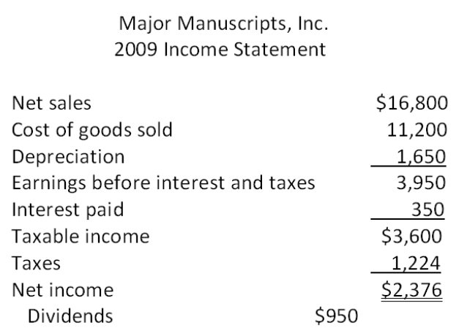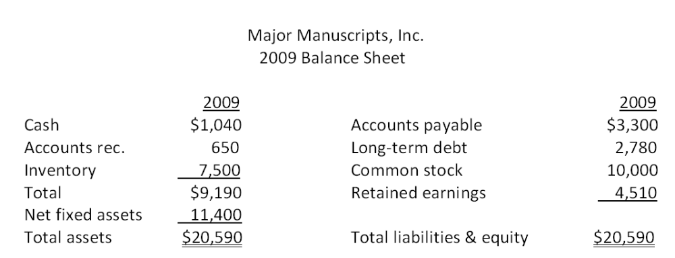

59. What is Major Manuscripts, Inc.'s retention ratio?
A. 33 percent
B. 40 percent
C. 50 percent
D. 60 percent
E. 67 percent

60. Major Manuscripts, Inc. does not want to incur any additional external financing. The dividend payout ratio is constant. What is the firm's maximum rate of growth?
A. 7.44 percent
B. 7.78 percent
C. 9.26 percent
D. 9.75 percent
E. 10.90 percent

61. If Major Manuscripts, Inc. decides to maintain a constant debt-equity ratio, what rate of growth can it maintain assuming that no additional external equity financing is available.
A. 10.23 percent
B. 10.49 percent
C. 10.90 percent
D. 11.27 percent
E. 11.65 percent

62. Major Manuscripts, Inc. is currently operating at maximum capacity. All costs, assets, and current liabilities vary directly with sales. The tax rate and the dividend payout ratio will remain constant. How much additional debt is required if no new equity is raised and sales are projected to increase by 8 percent?
A. -$157
B. -$68
C. $241
D. $348
E. $367

63. Major Manuscripts, Inc. is currently operating at 85 percent of capacity. All costs and net working capital vary directly with sales. The tax rate, the profit margin, and the dividend payout ratio will remain constant. How much additional debt is required if no new equity is raised and sales are projected to increase by 15 percent?
A. -$810
B. -$756
C. -$642
D. $244
E. $358

64. Assume the profit margin and the payout ratio of Major Manuscripts, Inc. are constant. If sales increase by 6 percent, what is the pro forma retained earnings?
A. $5,220.18
B. $5,721.42
C. $6,021.56
D. $6,648.42
E. $7,028.56

65. Assume that Major Manuscripts, Inc. is currently operating at 95 percent of capacity and that sales are projected to increase to $20,000. What is the projected addition to fixed assets?
A. $0
B. $1,493
C. $1,529
D. $1,546
E. $1,588

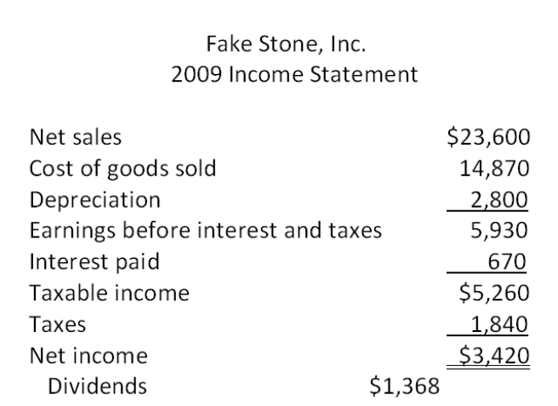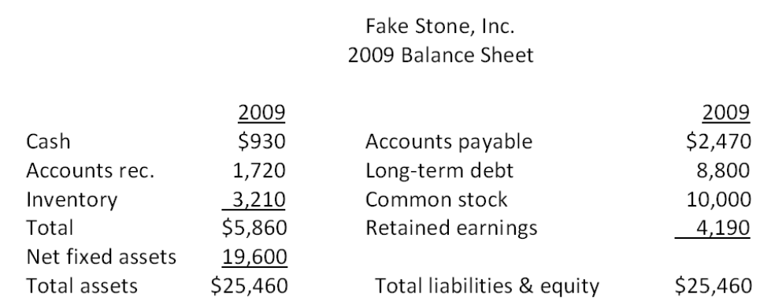

66. All of Fake Stone's costs and net working capital vary directly with sales. Sales are projected to increase by 3.5 percent. What is the pro forma accounts receivable balance for next year?
A. $1,659.80
B. $1,661.84
C. $1,780.20
D. $1,787.80
E. $1,800.46

67. The profit margin, the debt-equity ratio, and the dividend payout ratio for Fake Stone, Inc. are constant. Sales are expected to increase by $1,062 next year. What is the projected addition to retained earnings for next year?
A. $92.34
B. $188.55
C. $1,909.16
D. $2,144.34
E. $2,386.08

68. Assume that Fake Stone, Inc. is operating at full capacity. Also assume that all costs, net working capital, and fixed assets vary directly with sales. The debt-equity ratio and the dividend payout ratio are constant. What is the pro forma net fixed asset value for next year if sales are projected to increase by 7.5 percent?
A. $19,800
B. $21,070
C. $23,600
D. $24,240
E. $26,810

69. Assume that Fake Stone, Inc. is operating at 88 percent of capacity. All costs and net working capital vary directly with sales. What is the amount of the pro forma net fixed assets for next year if sales are projected to increase by 13 percent?
A. $19,600
B. $20,406
C. $21,500
D. $21,667
E. $22,148

70. Assume that Fake Stone, Inc. is operating at full capacity. Also assume that assets, costs, and current liabilities vary directly with sales. The dividend payout ratio is constant. What is the external financing need if sales increase by 12 percent?
A. -$318.09
B. -$268.49
C. $103.13
D. $350.40
E. $460.56

71. Fake Stone, Inc. is projecting sales to decrease by 4 percent next year while the profit margin remains constant. The firm wants to increase the dividend payout ratio by 2 percent. What is the projected increase in retained earnings for next year?
A. $1,711.15
B. $1,898.67
C. $1,943.65
D. $1,969.92
E. $2,105.63

72. What is the internal growth rate of Fake Stone, Inc. assuming the payout ratio remains constant?
A. 5.20 percent
B. 5.55 percent
C. 7.36 percent
D. 7.49 percent
E. 8.77 percent

73. What are the pro forma retained earnings for next year if Fake Stone, Inc. grows at a rate of 2.5 percent and both the profit margin and the dividend payout ratio remain constant?
A. $4,946.90
B. $5,023.10
C. $5,592.20
D. $5,920.67
E. $6,293.30

74. Assume that net working capital and all of the costs of Fake Stone, Inc. increase directly with sales. Also assume that the tax rate and the dividend payout ratio are constant. The firm is currently operating at full capacity. What is the external financing need if sales increase by 4 percent?
A. -$1,214.48
B. -$804.15
C. -$397.19
D. $201.16
E. $525.38

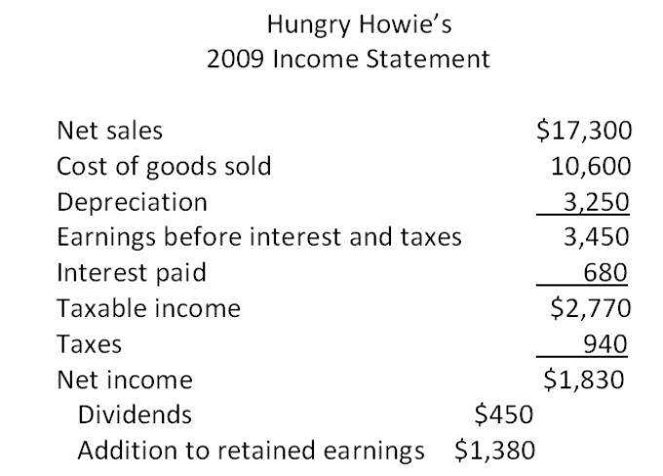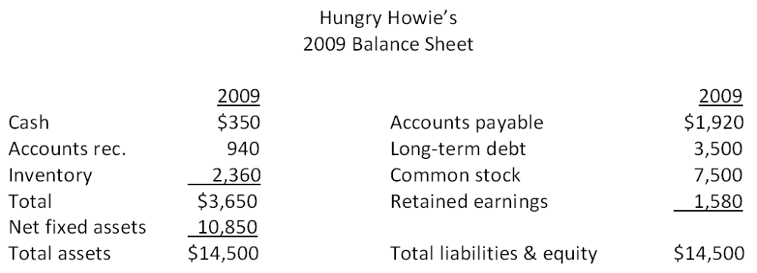

75. Hungry Howie's is currently operating at 78 percent of capacity. What is the full-capacity level of sales?
A. $21,106.00
B. $21,580.62
C. $22,179.49
D. $24,506.17
E. $25,301.91

76. Hungry Howie's is currently operating at 82 percent of capacity. What is the total asset turnover ratio at full capacity?
A. .68
B. .78
C. .95
D. 1.29
E. 1.46

77. Hungry Howie's is currently operating at 96 percent of capacity. The profit margin and the dividend payout ratio are projected to remain constant. Sales are projected to increase by 3 percent next year. What is the projected addition to retained earnings for next year?
A. $1,309.19
B. $1,421.40
C. $1,884.90
D. $2,667.78
E. $3,001.40

78. Hungry Howie's is currently operating at full capacity. The profit margin and the dividend payout ratio are held constant. Net working capital and fixed assets vary directly with sales. Sales are projected to increase by 11 percent. What is the external financing needed?
A. -$196.50
B. -$148.00
C. -$97.20
D. -$14.50
E. $26.80

79. Hungry Howie's maintains a constant payout ratio. The firm is currently operating at full capacity. What is the maximum rate at which the firm can grow without acquiring any additional external financing?
A. 9.74 percent
B. 10.52 percent
C. 11.06 percent
D. 11.58 percent
E. 12.23 percent

80. Hungry Howie's is currently operating at 94 percent of capacity. What is the required increase in fixed assets if sales are projected to increase by 14 percent?
A. $0
B. $511
C. $633
D. $708
E. $777

Essay Questions
81. Why do financial managers need to understand the implications of both the internal and the sustainable rates of growth?

82. Identify the four primary determinants of a firm's growth and explain how each factor could either add to or limit the growth potential of a firm.

83. A) What are the assumptions that underlie the internal growth rate and B) what are the implications of this rate?

84. Nelson's Landscaping Services just completed a pro forma statement using the percentage of sales approach. The pro forma has a projected external financing need of -$5,500. What are the firm's options in this case?

85. Smith & Daughters is getting ready to compile pro forma statements for the next few years. How can the managers establish a reasonable range of growth rates that they should consider during this planning process?

Multiple Choice Questions
86. The most recent financial statements for Watchtower, Inc. are shown here (assuming no income taxes):
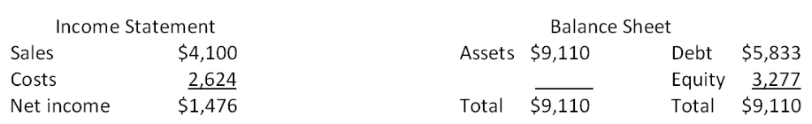
Assets and costs are proportional to sales. Debt and equity are not. No dividends are paid. Next year's sales are projected to be $5,002. What is the amount of the external financing need?
A. $197
B. $203
C. $211
D. $218
E. $223

87. The most recent financial statements for Last in Line, Inc. are shown here:
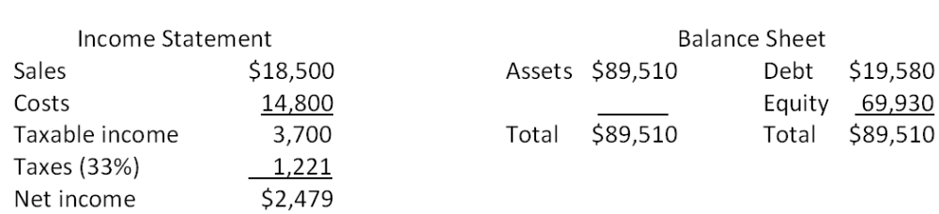
Assets and costs are proportional to sales. Debt and equity are not. A dividend of $992 was paid, and the company wishes to maintain a constant payout ratio. Next year's sales are projected to be $21,830. What is the amount of the external financing need?
A. $12,711
B. $13,333
C. $13,556
D. $13,809
E. $14,357

88. The most recent financial statements for 7 Seas, Inc. are shown here:
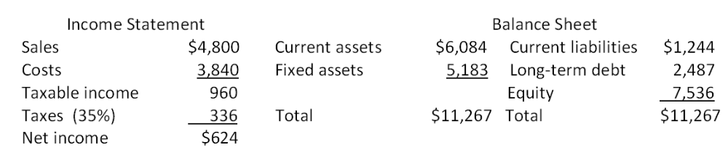
Assets, costs, and current liabilities are proportional to sales. Long-term debt and equity are not. The company maintains a constant 50 percent dividend payout ratio. Like every other firm in its industry, next year's sales are projected to increase by exactly 16 percent. What is the external financing need?
A. $1,241.76
B. $1,411.16
C. $1,583.09
D. $2,211.87
E. $2,349.98

89. The most recent financial statements for Benatar Co. are shown here:
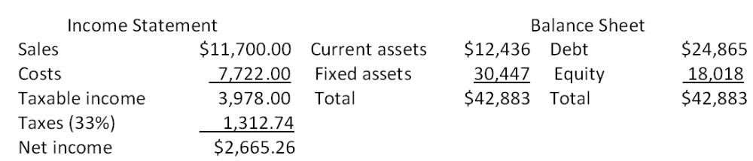
Assets and costs are proportional to sales. Debt and equity are not. The company maintains a constant 40 percent dividend payout ratio. No external equity financing is possible. What is the internal growth rate?
A. 2.91 percent
B. 3.44 percent
C. 3.87 percent
D. 4.02 percent
E. 4.14 percent

90. The most recent financial statements for Heng Co. are shown here:
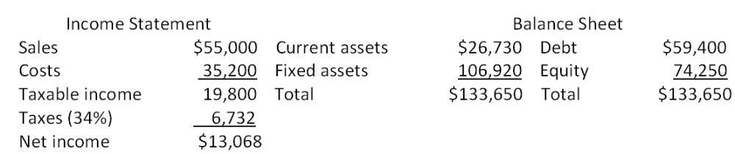
Assets and costs are proportional to sales. The company maintains a constant 40 percent dividend payout ratio and a constant debt-equity ratio. What is the maximum increase in sales that can be sustained next year assuming no new equity is issued?
A. $4,808.12
B. $5,211.17
C. $5,987.48
D. $6,493.74
E. $6,666.67

91. Consider the income statement for Heir Jordan Corporation:
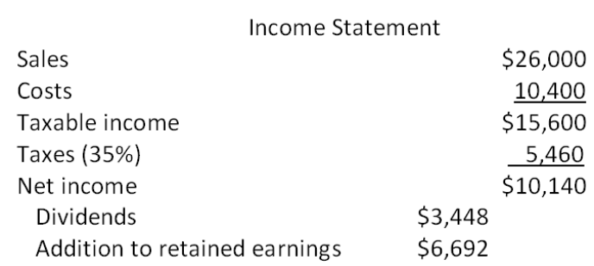
A 22 percent growth rate in sales is projected. What is the pro forma addition to retained earnings assuming all costs vary proportionately with sales?
A. $6,299
B. $7,303
C. $7,890
D. $8,011
E. $8,164

92. The Soccer Shoppe has a 7 percent return on assets and a 25 percent payout ratio. What is its internal growth rate?
A. 3.72 percent
B. 4.08 percent
C. 4.49 percent
D. 5.23 percent
E. 5.54 percent

93. The Parodies Corp. has a 22 percent return on equity and a 23 percent payout ratio. What is its sustainable growth rate?
A. 18.68 percent
B. 19.25 percent
C. 19.49 percent
D. 20.39 percent
E. 22.00 percent

94. Consider the following information for Kaleb's Kickboxing:
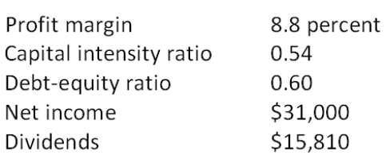
What is the sustainable rate of growth?
A. 13.87 percent
B. 14.29 percent
C. 14.65 percent
D. 15.42 percent
E. 15.58 percent

95. What is the sustainable growth rate assuming the following ratios are constant?
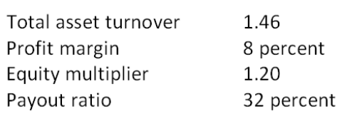
A. 10.30 percent
B. 10.53 percent
C. 10.67 percent
D. 10.89 percent
E. 11.01 percent

96. Seaweed Mfg., Inc. is currently operating at only 81 percent of fixed asset capacity. Current sales are $550,000. What is the maximum rate at which sales can grow before any new fixed assets are needed?
A. 14.23 percent
B. 14.47 percent
C. 15.03 percent
D. 22.87 percent
E. 23.46 percent

97. Seaweed Mfg., Inc. is currently operating at only 86 percent of fixed asset capacity. Fixed assets are $387,000. Current sales are $510,000 and are projected to grow to $664,000. What amount must be spent on new fixed assets to support this growth in sales?
A. $0
B. $22,654
C. $46,319
D. $79,408
E. $93,608

98. Fixed Appliance Co. wishes to maintain a growth rate of 8 percent a year, a constant debt-equity ratio of 0.34, and a dividend payout ratio of 52 percent. The ratio of total assets to sales is constant at 1.3. What profit margin must the firm achieve?
A. 13.92 percent
B. 14.46 percent
C. 14.97 percent
D. 15.33 percent
E. 15.74 percent

99. A firm wishes to maintain a growth rate of 8 percent and a dividend payout ratio of 62 percent. The ratio of total assets to sales is constant at 1, and the profit margin is 10 percent. What must the debt-equity ratio be if the firm wishes to keep that ratio constant?
A. 0.05
B. 0.40
C. 0.55
D. 0.60
E. 0.95

100. A firm wishes to maintain an internal growth rate of 11 percent and a dividend payout ratio of 24 percent. The current profit margin is 10 percent and the firm uses no external financing sources. What must the total asset turnover rate be?
A. 0.87 times
B. 0.90 times
C. 1.01 times
D. 1.15 times
E. 1.30 times

101. Based on the following information, what is the sustainable growth rate of Hendrix Guitars, Inc.?
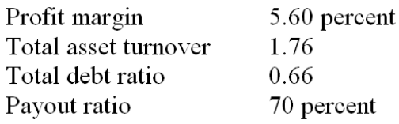
A. 7.68 percent
B. 9.52 percent
C. 11.12 percent
D. 13.49 percent
E. 14.41 percent

102. Country Comfort, Inc. had equity of $150,000 at the beginning of the year. At the end of the year, the company had total assets of $195,000. During the year, the company sold no new equity. Net income for the year was $72,000 and dividends were $44,640. What is the sustainable growth rate?
A. 15.32 percent
B. 15.79 percent
C. 17.78 percent
D. 18.01 percent
E. 18.24 percent

103. The most recent financial statements for Moose Tours, Inc. follow. Sales for 2009 are projected to grow by 16 percent. Interest expense will remain constant; the tax rate and dividend payout rate will also remain constant. Costs, other expenses, current assets, and accounts payable increase spontaneously will sales. If the firm is operating at full capacity and no new debt or equity is issued, how much external financing is needed to support the 16 percent growth rate in sales?
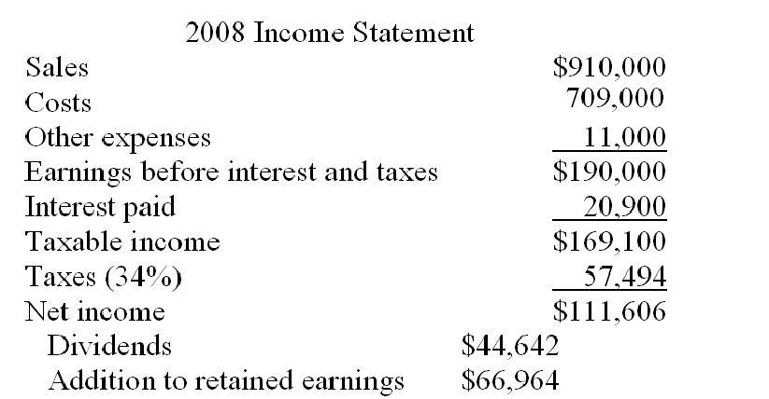
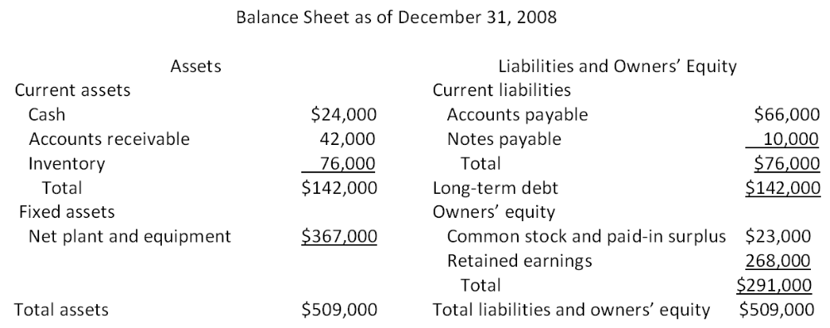
A. $-10,246
B. -$8,122
C. -$6,708
D. $2,407
E. $3,309

Chapter 04 Long-Term Financial Planning and Growth Answer Key

Multiple Choice Questions
1. Phil is working on a financial plan for the next three years. This time period is referred to as which one of the following?
A. financial range
B. planning horizon
C. planning agenda
D. short-run
E. current financing period
Refer to section 4.1

AACSB: N/A
Difficulty: Basic
Learning Objective: 4-1
Section: 4.1
Topic: Planning horizon
2. Atlas Industries combines the smaller investment proposals from each operational unit into a single project for planning purposes. This process is referred to as which one of the following?
A. conjoining
B. aggregation
C. conglomeration
D. appropriation
E. summation
Refer to section 4.1

AACSB: N/A
Difficulty: Basic
Learning Objective: 4-1
Section: 4.1
Topic: Aggregation
3. Which one of the following terms is applied to the financial planning method which uses the projected sales level as the basis for determining changes in balance sheet and income statement account values?
A. percentage of sales method
B. sales dilution method
C. sales reconciliation method
D. common-size method
E. trend method
Refer to section 4.3

AACSB: N/A
Difficulty: Basic
Learning Objective: 4-1
Section: 4.3
Topic: Percentage of sales approach
4. Which one of the following terms is defined as dividends paid expressed as a percentage of net income?
A. dividend retention ratio
B. dividend yield
C. dividend payout ratio
D. dividend portion
E. dividend section
Refer to section 4.3

AACSB: N/A
Difficulty: Basic
Learning Objective: 4-1
Section: 4.3
Topic: Dividend payout ratio
5. Which one of the following correctly defines the retention ratio?
A. one plus the dividend payout ratio
B. addition to retained earnings divided by net income
C. addition to retained earnings divided by dividends paid
D. net income minus additions to retained earnings
E. net income minus cash dividends
Refer to section 4.3

AACSB: N/A
Difficulty: Basic
Learning Objective: 4-1
Section: 4.3
Topic: Retention ratio
6. Which one of the following ratios identifies the amount of assets a firm needs in order to generate $1 in sales?
A. current ratio
B. equity multiplier
C. retention ratio
D. capital intensity ratio
E. payout ratio
Refer to section 4.3

AACSB: N/A
Difficulty: Basic
Learning Objective: 4-1
Section: 4.3
Topic: Capital intensity ratio
7. The internal growth rate of a firm is best described as the:
A. minimum growth rate achievable assuming a 100 percent retention ratio.
B. minimum growth rate achievable if the firm maintains a constant equity multiplier.
C. maximum growth rate achievable excluding external financing of any kind.
D. maximum growth rate achievable excluding any external equity financing while maintaining a constant debt-equity ratio.
E. maximum growth rate achievable with unlimited debt financing.
Refer to section 4.4

AACSB: N/A
Difficulty: Basic
Learning Objective: 4-3
Section: 4.4
Topic: Internal growth rate
8. The sustainable growth rate of a firm is best described as the:
A. minimum growth rate achievable assuming a 100 percent retention ratio.
B. minimum growth rate achievable if the firm maintains a constant equity multiplier.
C. maximum growth rate achievable excluding external financing of any kind.
D. maximum growth rate achievable excluding any external equity financing while maintaining a constant debt-equity ratio.
E. maximum growth rate achievable with unlimited debt financing.
Refer to section 4.4

AACSB: N/A
Difficulty: Basic
Learning Objective: 4-3
Section: 4.4
Topic: Sustainable growth rate
9. You are developing a financial plan for a corporation. Which of the following questions will be considered as you develop this plan?
I. How much net working capital will be needed?
II. Will additional fixed assets be required?
III. Will dividends be paid to shareholders?
IV. How much new debt must be obtained?
A. I and IV only
B. II and III only
C. I, III, and IV only
D. II, III, and IV only
E. I, II, III, and IV
Refer to the introduction to chapter 4

AACSB: N/A
Difficulty: Basic
Learning Objective: 4-1
Section: Introduction to chapter 4
Topic: Financial planning
10. Financial planning:
A. focuses solely on the short-term outlook for a firm.
B. is a process that firms employ only when major changes to a firm's operations are anticipated.
C. is a process that firms undergo once every five years.
D. considers multiple options and scenarios for the next two to five years.
E. provides minimal benefits for firms that are highly responsive to economic changes.
Refer to section 4.1

AACSB: N/A
Difficulty: Basic
Learning Objective: 4-1
Section: 4.1
Topic: Financial planning
11. Financial planning accomplishes which of the following for a firm?
I. determination of asset requirements
II. development of plans to contend with unexpected events
III. establishment of priorities
IV. analysis of funding options
A. I and III only
B. II and IV only
C. I, III, and IV only
D. I, II, and III only
E. I, II, III, and IV
Refer to section 4.1

AACSB: N/A
Difficulty: Basic
Learning Objective: 4-1
Section: 4.1
Topic: Financial planning
12. Which of the following questions are appropriate to address during the financial planning process?
I. Should the firm merge with a competitor?
II. Should additional shares of stock be sold?
III. Should a particular division be sold?
IV. Should a new product be introduced?
A. I, II, and III only
B. I, II, and IV only
C. I, III, and IV only
D. II, III, and IV only
E. I, II, III, and IV
Refer to section 4.1

AACSB: N/A
Difficulty: Basic
Learning Objective: 4-1
Section: 4.1
Topic: Financial planning
13. Which one of the following statements concerning financial planning for a firm is correct?
A. Financial planning for fixed assets is done on a segregated basis within each division.
B. Financial plans often contain alternative options based on economic developments.
C. Financial plans frequently contain conflicting goals.
D. Financial plans assume that firms obtain no additional external financing.
E. The financial planning process is based on a single set of economic assumptions.
Refer to section 4.1

AACSB: N/A
Difficulty: Basic
Learning Objective: 4-1
Section: 4.1
Topic: Financial planning
14. You are getting ready to prepare pro forma statements for your business. Which one of the following are you most apt to estimate first as you begin this process?
A. fixed assets
B. current expenses
C. sales forecast
D. projected net income
E. external financing need
Refer to section 4.1

AACSB: N/A
Difficulty: Basic
Learning Objective: 4-1
Section: 4.1
Topic: Pro forma statement
15. Which one of the following statements is correct?
A. Pro forma statements must assume that no new equity is issued.
B. Pro forma statements are projections, not guarantees.
C. Pro forma statements are limited to a balance sheet and income statement.
D. Pro forma financial statements must assume that no dividends will be paid.
E. Net working capital needs are excluded from pro forma computations.
Refer to section 4.2

AACSB: N/A
Difficulty: Basic
Learning Objective: 4-1
Section: 4.2
Topic: Pro forma statements
16. When utilizing the percentage of sales approach, managers:
I. estimate company sales based on a desired level of net income and the current profit margin.
II. consider only those assets that vary directly with sales.
III. consider the current production capacity level.
IV. can project both net income and net cash flows.
A. I and II only
B. II and III only
C. III and IV only
D. I, III, and IV only
E. II, III, and IV only
Refer to section 4.3

AACSB: N/A
Difficulty: Basic
Learning Objective: 4-1
Section: 4.3
Topic: Percentage of sales approach
17. Which one of the following is correct in relation to pro forma statements?
A. Fixed assets must increase if sales are projected to increase.
B. Net working capital is affected only when a firm's sales are expected to exceed the firm's current production capacity.
C. The addition to retained earnings is equal to net income plus dividends paid.
D. Long-term debt varies directly with sales when a firm is currently operating at maximum capacity.
E. Inventory changes are directly proportional to sales changes.
Refer to section 4.3

AACSB: N/A
Difficulty: Basic
Learning Objective: 4-1
Section: 4.3
Topic: Pro forma statements
18. When constructing a pro forma statement, net working capital generally:
A. remains fixed.
B. varies only if the firm is currently producing at full capacity.
C. varies only if the firm maintains a fixed debt-equity ratio.
D. varies only if the firm is producing at less than full capacity.
E. varies proportionally with sales.
Refer to section 4.3

AACSB: N/A
Difficulty: Basic
Learning Objective: 4-1
Section: 4.3
Topic: Pro forma statement
19. A pro forma statement indicates that both sales and fixed assets are projected to increase by 7 percent over their current levels. Given this, you can safely assume that the firm:
A. is projected to grow at the internal rate of growth.
B. is projected to grow at the sustainable rate of growth.
C. currently has excess capacity.
D. is currently operating at full capacity.
E. retains all of its net income.
Refer to section 4.3

AACSB: N/A
Difficulty: Basic
Learning Objective: 4-1
Section: 4.3
Topic: Pro forma statement
20. A firm is currently operating at full capacity. Net working capital, costs, and all assets vary directly with sales. The firm does not wish to obtain any additional equity financing. The dividend payout ratio is constant at 40 percent. If the firm has a positive external financing need, that need will be met by:
A. accounts payable.
B. long-term debt.
C. fixed assets.
D. retained earnings.
E. common stock.
Refer to section 4.3

AACSB: N/A
Difficulty: Basic
Learning Objective: 4-2
Section: 4.3
Topic: External financing need
21. Which one of the following policies most directly affects the projection of the retained earnings balance to be used on a pro forma statement?
A. net working capital policy
B. capital structure policy
C. dividend policy
D. capital budgeting policy
E. capacity utilization policy
Refer to section 4.3

AACSB: N/A
Difficulty: Basic
Learning Objective: 4-1
Section: 4.3
Topic: Pro forma statement
22. You are comparing the current income statement of a firm to the pro forma income statement for next year. The pro forma is based on a four percent increase in sales. The firm is currently operating at 85 percent of capacity. Net working capital and all costs vary directly with sales. The tax rate and the dividend payout ratio are fixed. Given this information, which one of the following statements must be true?
A. The projected net income is equal to the current year's net income.
B. The tax rate will increase at the same rate as sales.
C. Retained earnings will increase by four percent over its current level.
D. Total assets will increase by less than four percent.
E. Total liabilities and owners' equity will increase by four percent.
Refer to section 4.3

AACSB: N/A
Difficulty: Intermediate
Learning Objective: 4-1
Section: 4.3
Topic: Pro forma statement
23. A firm is operating at 90 percent of capacity. This information is primarily needed to project which one of the following account values when compiling pro forma statements?
A. sales
B. costs of goods sold
C. accounts receivable
D. fixed assets
E. long-term debt
Refer to section 4.3

AACSB: N/A
Difficulty: Basic
Learning Objective: 4-1
Section: 4.3
Topic: Pro forma statements
24. Which one of the following capital intensity ratios indicates the largest need for fixed assets per dollar of sales?
A. 0.70
B. 0.86
C. 1.00
D. 1.06
E. 1.15
Refer to section 4.3

AACSB: N/A
Difficulty: Basic
Learning Objective: 4-1
Section: 4.3
Topic: Capital intensity ratio
25. Which of the following are needed to determine the amount of fixed assets required to support each dollar of sales?
I. current amount of fixed assets
II. current sales
III. current level of operating capacity
IV. projected growth rate of sales
A. I and III only
B. II and IV only
C. I, II, and III only
D. II, III, and IV only
E. I, II, III, and IV
Refer to section 4.3

AACSB: N/A
Difficulty: Intermediate
Learning Objective: 4-1
Section: 4.3
Topic: Capital intensity ratio
26. The plowback ratio is:
A. equal to net income divided by the change in total equity.
B. the percentage of net income available to the firm to fund future growth.
C. equal to one minus the retention ratio.
D. the change in retained earnings divided by the dividends paid.
E. the dollar increase in net income divided by the dollar increase in sales.
Refer to section 4.3

AACSB: N/A
Difficulty: Basic
Learning Objective: 4-1
Section: 4.3
Topic: Plowback ratio
27. A firm's net working capital and all of its expenses vary directly with sales. The firm is operating currently at 96 percent of capacity. The firm wants no additional external financing of any kind. Which one of the following statements related to the firm's pro forma statements for next year must be correct?
A. Total liabilities will remain constant at this year's value.
B. The maximum rate of sales increase is 4 percent.
C. The firm cannot exceed its internal rate of growth.
D. The projected owners' equity will equal this year's ending equity balance.
E. Fixed assets must remain constant at the current level.
Refer to section 4.4

AACSB: N/A
Difficulty: Intermediate
Learning Objective: 4-1
Section: 4.4
Topic: Internal rate of growth
28. Which one of the following will increase the maximum rate of growth a corporation can achieve?
A. avoidance of external equity financing
B. increase in corporate tax rates
C. reduction in the retention ratio
D. decrease in the dividend payout ratio
E. decrease in sales given a positive profit margin
Refer to section 4.4

AACSB: N/A
Difficulty: Intermediate
Learning Objective: 4-3
Section: 4.4
Topic: Growth rates
29. Martin Aerospace is currently operating at full capacity based on its current level of assets. Sales are expected to increase by 4.5 percent next year, which is the firm's internal rate of growth. Net working capital and operating costs are expected to increase directly with sales. The interest expense will remain constant at its current level. The tax rate and the dividend payout ratio will be held constant. Current and projected net income is positive. Which one of the following statements is correct regarding the pro forma statement for next year?
A. The pro forma profit margin is equal to the current profit margin.
B. Retained earnings will increase at the same rate as sales.
C. Total assets will increase at the same rate as sales.
D. Long-term debt will increase in direct relation to sales.
E. Owners' equity will remain constant.
Refer to section 4.3

AACSB: N/A
Difficulty: Intermediate
Learning Objective: 4-1
Section: 4.3
Topic: Pro forma statement
30. A firm's external financing need is financed by which of the following?
A. retained earnings
B. net working capital and retained earnings
C. net income and retained earnings
D. debt or equity
E. owners' equity, including retained earnings
Refer to section 4.3

AACSB: N/A
Difficulty: Basic
Learning Objective: 4-2
Section: 4.3
Topic: External financing need
31. Sales can often increase without increasing which one of the following?
A. accounts receivable
B. cost of goods sold
C. accounts payable
D. fixed assets
E. inventory
Refer to section 4.3

AACSB: N/A
Difficulty: Basic
Learning Objective: 4-1
Section: 4.3
Topic: Capacity level
32. Blasco Industries is currently at full-capacity sales. Which one of the following is limiting sales to this level?
A. net working capital
B. long-term debt
C. inventory
D. fixed assets
E. debt-equity ratio
Refer to section 4.3

AACSB: N/A
Difficulty: Basic
Learning Objective: 4-1
Section: 4.3
Topic: Full capacity sales
33. All else constant, which one of the following will increase the internal rate of growth?
A. decrease in the retention ratio
B. decrease in net income
C. increase in the dividend payout ratio
D. decrease in total assets
E. increase in costs of goods sold
Refer to section 4.4

AACSB: N/A
Difficulty: Intermediate
Learning Objective: 4-3
Section: 4.4
Topic: Internal rate of growth
34. The external financing need:
A. will limit growth if unfunded.
B. is unaffected by the dividend payout ratio.
C. must be funded by long-term debt.
D. ignores any changes in retained earnings.
E. considers only the required increase in fixed assets.
Refer to section 4.3

AACSB: N/A
Difficulty: Basic
Learning Objective: 4-2
Section: 4.3
Topic: External financing need
35. Which one of the following will cause the sustainable growth rate to equal to internal growth rate?
A. dividend payout ratio greater than 1.0
B. debt-equity ratio of 1.0
C. retention ratio between 0.0 and 1.0
D. equity multiplier of 1.0
E. zero dividend payments
Refer to section 4.4

AACSB: N/A
Difficulty: Intermediate
Learning Objective: 4-3
Section: 4.4
Topic: Growth rates
36. The sustainable growth rate:
A. assumes there is no external financing of any kind.
B. assumes no additional long-term debt is available.
C. assumes the debt-equity ratio is constant.
D. assumes the debt-equity ratio is 1.0.
E. assumes all income is retained by the firm.
Refer to section 4.4

AACSB: N/A
Difficulty: Basic
Learning Objective: 4-3
Section: 4.4
Topic: Sustainable growth rate
37. If a firm equates its pro forma sales growth to the rate of sustainable growth, and has positive net income and excess capacity, then the:
A. maximum capacity level will have to increase at the same rate as sales growth.
B. total assets will have to increase at the same rate as sales growth.
C. debt-equity ratio will increase.
D. retained earnings will increase.
E. number of common shares outstanding will increase.
Refer to section 4.4

AACSB: N/A
Difficulty: Intermediate
Learning Objective: 4-3
Section: 4.4
Topic: Sustainable growth
38. Sal's Pizza has a dividend payout ratio of 10 percent. The firm does not want to issue additional equity shares but does want to maintain its current debt-equity ratio and its current dividend policy. The firm is profitable. Which one of the following defines the maximum rate at which this firm can grow?
A. internal growth rate × (1 - 0.10)
B. sustainable growth rate × (1 - 0.10)
C. internal growth rate
D. sustainable growth rate
E. zero percent
Refer to section 4.4

AACSB: N/A
Difficulty: Basic
Learning Objective: 4-3
Section: 4.4
Topic: Sustainable growth rate
39. Which of the following can affect a firm's sustainable rate of growth?
I. capital intensity ratio
II. profit margin
III. dividend policy
IV. debt-equity ratio
A. III only
B. I and III only
C. II, III, and IV only
D. I, II, and IV only
E. I, II, III, and IV
Refer to section 4.4

AACSB: N/A
Difficulty: Intermediate
Learning Objective: 4-3
Section: 4.4
Topic: Sustainable growth rate
40. Financial plans generally tend to ignore which one of the following?
A. dividend policy
B. manager's goals and objectives
C. risks associated with cash flows
D. operating capacity levels
E. capital structure policy
Refer to section 4.5

AACSB: N/A
Difficulty: Basic
Learning Objective: 4-4
Section: 4.5
Topic: Financial plans
41. The financial planning process tends to place the least emphasis on which one of the following?
A. growth limitations
B. capacity utilization
C. market value of a firm
D. capital structure of a firm
E. dividend policy
Refer to section 4.5

AACSB: N/A
Difficulty: Basic
Learning Objective: 4-4
Section: 4.5
Topic: Financial planning
42. The financial planning process:
I. involves internal negotiations among divisions.
II. quantifies senior manager's goals.
III. considers only internal factors.
IV. reconciles company activities across divisions.
A. III and IV only
B. II and III only
C. I, II, and IV only
D. II, III, and IV only
E. I, II, III, and IV
Refer to section 4.5

AACSB: N/A
Difficulty: Intermediate
Learning Objective: 4-4
Section: 4.5
Topic: Financial planning process
43. A Procrustes approach to financial planning is based on:
A. a policy of producing a financial plan once every five years.
B. developing a plan around the goals of senior managers.
C. a proactive approach to the economic outlook.
D. a flexible capital budget.
E. a flexible capital structure.
Refer to section 4.5

AACSB: N/A
Difficulty: Basic
Learning Objective: 4-4
Section: 4.5
Topic: Procrustes approach
44. Fresno Salads has current sales of $4,900 and a profit margin of 6.5 percent. The firm estimates that sales will increase by 5 percent next year and that all costs will vary in direct relationship to sales. What is the pro forma net income?
A. $303.33
B. $327.18
C. $334.43
D. $338.70
E. $341.10
Net income = $4,900 × .065 × (1 + .05) = $334.43

AACSB: Analytic
Difficulty: Basic
Learning Objective: 4-1
Section: 4.3
Topic: Pro forma income
45. Wagner Industrial Motors, which is currently operating at full capacity, has sales of $29,000, current assets of $1,600, current liabilities of $1,200, net fixed assets of $27,500, and a 5 percent profit margin. The firm has no long-term debt and does not plan on acquiring any. The firm does not pay any dividends. Sales are expected to increase by 4.5 percent next year. If all assets, short-term liabilities, and costs vary directly with sales, how much additional equity financing is required for next year?
A. -$259.75
B. -$201.19
C. $967.30
D. $1,099.08
E. $1,515.25
Projected assets = ($1,600 + $27,500) × 1.045 = $30,409.50
Projected liabilities = $1,200 × 1.045 = $1,254
Current equity = $1,600 + $27,500 - $1,200 = $27,900
Projected increase in retained earnings = $29,000 × .05 × 1.045 = $1,515.25
Equity funding need = $30,409.50 - $1,254 - $27,900 - $1,515.25 = -$259.75

AACSB: Analytic
Difficulty: Basic
Learning Objective: 4-2
Section: 4.2
Topic: Equity financing
46. The Cookie Shoppe expects sales of $437,500 next year. The profit margin is 4.8 percent and the firm has a 30 percent dividend payout ratio. What is the projected increase in retained earnings?
A. $14,700
B. $17,500
C. $18,300
D. $20,600
E. $21,000
Change in retained earnings = $437,500 × .048 × (1 - 0.30) = $14,700

AACSB: Analytic
Difficulty: Basic
Learning Objective: 4-1
Section: 4.3
Topic: Retained earnings
47. Gladsden Refinishers currently has $21,900 in sales and is operating at 45 percent of the firm's capacity. What is the full capacity level of sales?
A. $31,755
B. $36,250
C. $48,667
D. $51,333
E. $54,500
Full-capacity sales = $21,900/0.45 = $48,667

AACSB: Analytic
Difficulty: Basic
Learning Objective: 4-1
Section: 4.3
Topic: Full capacity sales
48. The Corner Store has $219,000 of sales and $187,000 of total assets. The firm is operating at 87 percent of capacity. What is the capital intensity ratio at full capacity?
A. 0.62
B. 0.68
C. 0.74
D. 1.35
E. 1.47
Full-capacity sales = $219,000/0.87 = $251,724.14
Capital intensity ratio = $187,000/$251,724.14 = 0.74

AACSB: Analytic
Difficulty: Basic
Learning Objective: 4-1
Section: 4.3
Topic: Capital intensity ratio
49. Miller Bros. Hardware is operating at full capacity with a sales level of $689,700 and fixed assets of $468,000. The profit margin is 7 percent. What is the required addition to fixed assets if sales are to increase by 10 percent?
A. $3,276
B. $4,680
C. $28,400
D. $32,760
E. $46,800
Required addition to fixed assets = $468,000 × 0.10 = $46,800
Or, Capital intensity ratio = $468,000/$689,700 = 0.678556
Required addition to fixed assets = $689,700 × 0.10 × 0.678556 = $46,800

AACSB: Analytic
Difficulty: Basic
Learning Objective: 4-1
Section: 4.3
Topic: Fixed assets
50. Designer's Outlet has a capital intensity ratio of 0.87 at full capacity. Currently, total assets are $48,900 and current sales are $52,300. At what level of capacity is the firm currently operating?
A. 89 percent
B. 91 percent
C. 93 percent
D. 96 percent
E. 98 percent
Total capacity sales = $48,900/0.87 = $56,206.90
Current capacity utilization = $52,300/$56,206.90 = 93 percent

AACSB: Analytic
Difficulty: Intermediate
Learning Objective: 4-1
Section: 4.3
Topic: Capacity level
51. Monika's Dinor is operating at 94 percent of its fixed asset capacity and has current sales of $611,000. How much can the firm grow before any new fixed assets are needed?
A. 4.99 percent
B. 5.78 percent
C. 6.02 percent
D. 6.38 percent
E. 6.79 percent
Full-capacity sales = $611,000/0.94 = $650,000
Maximum growth without additional assets = ($650,000/$611,000) - 1 = 6.38 percent

AACSB: Analytic
Difficulty: Intermediate
Learning Objective: 4-1
Section: 4.3
Topic: Capacity and growth
52. Stop and Go has a 4.5 percent profit margin and a 15 percent dividend payout ratio. The total asset turnover is 1.6 and the debt-equity ratio is 0.60. What is the sustainable rate of growth?
A. 9.13 percent
B. 9.54 percent
C. 9.89 percent
D. 10.26 percent
E. 10.85 percent
Return on equity = 0.045 × 1.60 × (1 + 0.60) = 0.1152
Sustainable growth = [0.1152 × (1 - 0.15)]/{1 - [.1152 × (1 - 0.15)]} = 10.85 percent

AACSB: Analytic
Difficulty: Basic
Learning Objective: 4-3
Section: 4.4
Topic: Sustainable growth
53. R. N. C., Inc. desires a sustainable growth rate of 4.5 percent while maintaining a 40 percent dividend payout ratio and a 6 percent profit margin. The company has a capital intensity ratio of 1.23. What equity multiplier is required to achieve the company's desired rate of growth?
A. 1.33
B. 1.38
C. 1.42
D. 1.47
E. 1.53
0.045 = [ROE × (1 - 0.40)]/{1 - [ROE × (1 - 0.40)]}; ROE = .07177
0.07177 = 0.06 × (1/1.23) × EM; EM = 1.47

AACSB: Analytic
Difficulty: Intermediate
Learning Objective: 4-3
Section: 4.4
Topic: Equity multiplier
54. A firm has a retention ratio of 45 percent and a sustainable growth rate of 6.2 percent. The capital intensity ratio is 1.2 and the debt-equity ratio is 0.64. What is the profit margin?
A. 6.28 percent
B. 7.67 percent
C. 9.47 percent
D. 12.38 percent
E. 14.63 percent
0.062 = [ROE × 0.45]/[1 - (ROE × 0.45)]; ROE = .129734
0.129734 = PM × (1/1.2) × (1 + .064); PM = 14.63 percent

AACSB: Analytic
Difficulty: Intermediate
Learning Objective: 4-3
Section: 4.4
Topic: Profit margin
55. Frasier Cabinets wants to maintain a growth rate of 5 percent without incurring any additional equity financing. The firm maintains a constant debt-equity ratio of .0.55, a total asset turnover ratio of 1.30, and a profit margin of 9.0 percent. What must the dividend payout ratio be?
A. 26.26 percent
B. 38.87 percent
C. 49.29 percent
D. 61.13 percent
E. 73.74 percent
Return on equity = 0.09 × 1.30 × (1 + 0.55) = 0.18135
Sustainable growth = [0.18135 × b]/[1 - (0.18135 × b)] = .05; b = 0.2626
Payout ratio = 1 - 0.2626 = 73.74 percent

AACSB: Analytic
Difficulty: Intermediate
Learning Objective: 4-3
Section: 4.4
Topic: Payout ratio
56. Cross Town Express has sales of $132,000, net income of $12,600, total assets of $98,000, and total equity of $45,000. The firm paid $7,560 in dividends and maintains a constant dividend payout ratio. Currently, the firm is operating at full capacity. All costs and assets vary directly with sales. The firm does not want to obtain any additional external equity. At the sustainable rate of growth, how much new total debt must the firm acquire?
A. $0
B. $4,311
C. $5,989
D. $6,207
E. $6,685
Dividend payout ratio = $7,560/$12,600 = 0.60
Retention ratio = 1 - 0.60 = 0.40
Sustainable growth = [($12,600/$45,000) × 0.40]/{1 - [($12,600/$45,000) × 0.40]} = 0.126126
Projected total assets = $98,000 × 1.126126 = $110,360.35
Current debt = $98,000 - $45,000 = $53,000
Projected equity = $45,000 + ($12,600 × 1.126126 × 0.40) = $50,675.68
Net debt required = $110,360.35 - $53,000 - $50,675.68 = $6,685

AACSB: Analytic
Difficulty: Intermediate
Learning Objective: 4-2
Section: 4.4
Topic: External financing need
57. The Two Sisters has a 9 percent return on assets and a 75 percent retention ratio. What is the internal growth rate?
A. 6.50 percent
B. 6.75 percent
C. 6.97 percent
D. 7.24 percent
E. 7.38 percent
Internal growth rate = (0.09 × 0.75)/[1 - (0.09 × 0.75)] = 7.24 percent

AACSB: Analytic
Difficulty: Basic
Learning Objective: 4-3
Section: 4.4
Topic: Internal growth rate
58. The Dog House has net income of $3,450 and total equity of $8,600. The debt-equity ratio is 0.60 and the payout ratio is 20 percent. What is the internal growth rate?
A. 14.47 percent
B. 17.78 percent
C. 25.09 percent
D. 29.40 percent
E. 33.33 percent
Total assets = $8,600 × (1 + 0.60) = $13,760
Return on assets = $3,450/$13,760 = .250727
Internal growth = [.250727 × (1 - 0.20]/[1 - (.250727 × (1 - 0.20)] = 25.09 percent

AACSB: Analytic
Difficulty: Intermediate
Learning Objective: 4-3
Section: 4.4
Topic: Internal growth rate

59. What is Major Manuscripts, Inc.'s retention ratio?
A. 33 percent
B. 40 percent
C. 50 percent
D. 60 percent
E. 67 percent
Retention ratio = ($2,376 - $950)/$2,376 = 60 percent

AACSB: Analytic
Difficulty: Basic
Learning Objective: 4-1
Section: 4.3
Topic: Retention ratio
60. Major Manuscripts, Inc. does not want to incur any additional external financing. The dividend payout ratio is constant. What is the firm's maximum rate of growth?
A. 7.44 percent
B. 7.78 percent
C. 9.26 percent
D. 9.75 percent
E. 10.90 percent
Retention ratio = ($2,376 - $950)/$2,376 = 0.60
Internal growth rate = [($2,376/$20,590) × 0.60]/{1 - [($2,376/$20,590) × 0.60]} = 7.44 percent

AACSB: Analytic
Difficulty: Basic
Learning Objective: 4-3
Section: 4.4
Topic: Internal growth rate
61. If Major Manuscripts, Inc. decides to maintain a constant debt-equity ratio, what rate of growth can it maintain assuming that no additional external equity financing is available.
A. 10.23 percent
B. 10.49 percent
C. 10.90 percent
D. 11.27 percent
E. 11.65 percent
Retention ratio = ($2,376 - $950)/$2,376 = 0.60
Sustainable growth rate = {[$2,376/($10,000 + $4,510)] × 0.60}/(expression error) = 10.90 percent

AACSB: Analytic
Difficulty: Basic
Learning Objective: 4-3
Section: 4.4
Topic: Sustainable growth rate
62. Major Manuscripts, Inc. is currently operating at maximum capacity. All costs, assets, and current liabilities vary directly with sales. The tax rate and the dividend payout ratio will remain constant. How much additional debt is required if no new equity is raised and sales are projected to increase by 8 percent?
A. -$157
B. -$68
C. $241
D. $348
E. $367
Projected total assets = $20,590 × 1.08 = $22,237
Projected accounts payable = $3,300 × 1.08 = $3,564
Current long-term debt = $2,780
Current common stock = $10,000
Projected retained earnings = $4,510 + [($2,376 - $950) × 1.08] = $6,050
Additional debt required = $22,237 - $3,564 - $2,780 - $10,000 - $6,050 = -$157

AACSB: Analytic
Difficulty: Intermediate
Learning Objective: 4-2
Section: 4.3
Topic: External financing need
63. Major Manuscripts, Inc. is currently operating at 85 percent of capacity. All costs and net working capital vary directly with sales. The tax rate, the profit margin, and the dividend payout ratio will remain constant. How much additional debt is required if no new equity is raised and sales are projected to increase by 15 percent?
A. -$810
B. -$756
C. -$642
D. $244
E. $358
Projected current assets = $9,190 × 1.15 = $10,568.50
Projected capacity level = 0.85 × 1.15 = 0.9775 (Will not exceed excess capacity.)
Projected fixed assets = $11,400
Projected accounts payable = $3,300 × 1.15 = $3,795
Current long-term debt = $2,780
Current common stock = $10,000
Projected retained earnings = $4,510 + [($2,376 - $950) × 1.15] = $6,149.90
Additional debt required = $10,568.50 + $11,400 - $3,795 - $2,780 - $10,000 - $6,149.90 = -$756

AACSB: Analytic
Difficulty: Intermediate
Learning Objective: 4-2
Section: 4.3
Topic: External financing need
64. Assume the profit margin and the payout ratio of Major Manuscripts, Inc. are constant. If sales increase by 6 percent, what is the pro forma retained earnings?
A. $5,220.18
B. $5,721.42
C. $6,021.56
D. $6,648.42
E. $7,028.56
Pro forma retained earnings = $4,510 + [($2,376 - $950) × 1.06)] = $6,021.56

AACSB: Analytic
Difficulty: Basic
Learning Objective: 4-1
Section: 4.3
Topic: Pro forma
65. Assume that Major Manuscripts, Inc. is currently operating at 95 percent of capacity and that sales are projected to increase to $20,000. What is the projected addition to fixed assets?
A. $0
B. $1,493
C. $1,529
D. $1,546
E. $1,588
Current maximum capacity = $16,800/.95 = $17,684.21
Required addition to fixed assets = [($11,400/$17,684.21) × $20,000] - $11,400 = $1,493

AACSB: Analytic
Difficulty: Intermediate
Learning Objective: 4-1
Section: 4.3
Topic: Fixed assets

66. All of Fake Stone's costs and net working capital vary directly with sales. Sales are projected to increase by 3.5 percent. What is the pro forma accounts receivable balance for next year?
A. $1,659.80
B. $1,661.84
C. $1,780.20
D. $1,787.80
E. $1,800.46
Pro forma accounts receivable = $1,720 × (1 + .035) = $1,780.20

AACSB: Analytic
Difficulty: Basic
Learning Objective: 4-1
Section: 4.3
Topic: Pro forma
67. The profit margin, the debt-equity ratio, and the dividend payout ratio for Fake Stone, Inc. are constant. Sales are expected to increase by $1,062 next year. What is the projected addition to retained earnings for next year?
A. $92.34
B. $188.55
C. $1,909.16
D. $2,144.34
E. $2,386.08
Projected change in retained earnings = [($23,600 + $1,062)/$23,600] × ($3,420 - $1,368) = $2,144.34

AACSB: Analytic
Difficulty: Basic
Learning Objective: 4-1
Section: 4.3
Topic: Retained earnings
68. Assume that Fake Stone, Inc. is operating at full capacity. Also assume that all costs, net working capital, and fixed assets vary directly with sales. The debt-equity ratio and the dividend payout ratio are constant. What is the pro forma net fixed asset value for next year if sales are projected to increase by 7.5 percent?
A. $19,800
B. $21,070
C. $23,600
D. $24,240
E. $26,810
Pro forma net fixed assets = $19,600 × (1 + 0.075) = $21,070

AACSB: Analytic
Difficulty: Basic
Learning Objective: 4-1
Section: 4.3
Topic: Pro forma
69. Assume that Fake Stone, Inc. is operating at 88 percent of capacity. All costs and net working capital vary directly with sales. What is the amount of the pro forma net fixed assets for next year if sales are projected to increase by 13 percent?
A. $19,600
B. $20,406
C. $21,500
D. $21,667
E. $22,148
Pro forma capacity level = 0.88 × (1 + 0.13) = 99.44 percent.
No additional fixed assets are required. Thus, fixed assets will remain at $19,600.

AACSB: Analytic
Difficulty: Basic
Learning Objective: 4-1
Section: 4.3
Topic: Fixed assets
70. Assume that Fake Stone, Inc. is operating at full capacity. Also assume that assets, costs, and current liabilities vary directly with sales. The dividend payout ratio is constant. What is the external financing need if sales increase by 12 percent?
A. -$318.09
B. -$268.49
C. $103.13
D. $350.40
E. $460.56
External financing needed = (1.12 × $25,460) - (1.12 × $2,470) - $8,800 - $10,000 - $4,190 - [$3,420 - $1,368 × 1.12] = $460.56

AACSB: Analytic
Difficulty: Basic
Learning Objective: 4-2
Section: 4.4
Topic: External financing need
71. Fake Stone, Inc. is projecting sales to decrease by 4 percent next year while the profit margin remains constant. The firm wants to increase the dividend payout ratio by 2 percent. What is the projected increase in retained earnings for next year?
A. $1,711.15
B. $1,898.67
C. $1,943.65
D. $1,969.92
E. $2,105.63
Projected dividend payout ratio = ($1,368/$3,420) × 1.02 = 0.408
Retention ratio = 1 - 0.408 = 0.592
Projected increase in retained earnings = $3,420 × (1 - 0.04) × 0.592 = $1,943.65

AACSB: Analytic
Difficulty: Basic
Learning Objective: 4-1
Section: 4.3
Topic: Retained earnings
72. What is the internal growth rate of Fake Stone, Inc. assuming the payout ratio remains constant?
A. 5.20 percent
B. 5.55 percent
C. 7.36 percent
D. 7.49 percent
E. 8.77 percent
Internal growth = {($3,420/$25,460) × [1 - ($1,368/$3,420)]}/(expression error) = 8.77 percent

AACSB: Analytic
Difficulty: Basic
Learning Objective: 4-3
Section: 4.4
Topic: Internal growth rate
73. What are the pro forma retained earnings for next year if Fake Stone, Inc. grows at a rate of 2.5 percent and both the profit margin and the dividend payout ratio remain constant?
A. $4,946.90
B. $5,023.10
C. $5,592.20
D. $5,920.67
E. $6,293.30
Pro forma retained earnings = $4,190 + [($3,420 - $1,368) × 1.025)] = $6,293.30

AACSB: Analytic
Difficulty: Basic
Learning Objective: 4-1
Section: 4.4
Topic: Retained earnings
74. Assume that net working capital and all of the costs of Fake Stone, Inc. increase directly with sales. Also assume that the tax rate and the dividend payout ratio are constant. The firm is currently operating at full capacity. What is the external financing need if sales increase by 4 percent?
A. -$1,214.48
B. -$804.15
C. -$397.19
D. $201.16
E. $525.38
Projected total assets = $25,460 × 1.04 = $26,478.40
Projected accounts payable = $2,470 × 1.04 = $2,568.80
Projected retained earnings = $4,190 + [($3,420 - $1,368) × 1.04] = $6,324.08
External financing need = $26,478.40 - $2,568.80 - $8,800 - $10,000 - $6,324.08 = -$1,214.48

AACSB: Analytic
Difficulty: Basic
Learning Objective: 4-2
Section: 4.4
Topic: External financing need

75. Hungry Howie's is currently operating at 78 percent of capacity. What is the full-capacity level of sales?
A. $21,106.00
B. $21,580.62
C. $22,179.49
D. $24,506.17
E. $25,301.91
Full-capacity sales = $17,300/0.78 = $22,179.49

AACSB: Analytic
Difficulty: Basic
Learning Objective: 4-1
Section: 4.3
Topic: Capacity level sales
76. Hungry Howie's is currently operating at 82 percent of capacity. What is the total asset turnover ratio at full capacity?
A. .68
B. .78
C. .95
D. 1.29
E. 1.46
Full-capacity sales = $17,300/0.82 = $21,097.56
Total asset turnover at full-capacity = $21,097.56/$14,500 = 1.46

AACSB: Analytic
Difficulty: Intermediate
Learning Objective: 4-1
Section: 4.3
Topic: Total asset turnover
77. Hungry Howie's is currently operating at 96 percent of capacity. The profit margin and the dividend payout ratio are projected to remain constant. Sales are projected to increase by 3 percent next year. What is the projected addition to retained earnings for next year?
A. $1,309.19
B. $1,421.40
C. $1,884.90
D. $2,667.78
E. $3,001.40
Projected addition to retained earnings = $1,380 × (1 + .03) = $1,421.40

AACSB: Analytic
Difficulty: Basic
Learning Objective: 4-1
Section: 4.3
Topic: Retained earnings
78. Hungry Howie's is currently operating at full capacity. The profit margin and the dividend payout ratio are held constant. Net working capital and fixed assets vary directly with sales. Sales are projected to increase by 11 percent. What is the external financing needed?
A. -$196.50
B. -$148.00
C. -$97.20
D. -$14.50
E. $26.80
Projected total assets = $14,500 × 1.11 = $16,095
Projected accounts payable = $1,920 × 1.11 = $2,131.20
Projected retained earnings = $1,580 + ($1,380 × 1.11) = $3,111.80
External financing need = $16,095 - $2,131.20 - $3,500 - $7,500 - $3,111.80 = -$148

AACSB: Analytic
Difficulty: Basic
Learning Objective: 4-2
Section: 4.4
Topic: External financing need
79. Hungry Howie's maintains a constant payout ratio. The firm is currently operating at full capacity. What is the maximum rate at which the firm can grow without acquiring any additional external financing?
A. 9.74 percent
B. 10.52 percent
C. 11.06 percent
D. 11.58 percent
E. 12.23 percent
Internal growth = [($1,830/$14,500) × ($1,380/$1,830)]/{1 - [($1,830/$14,500) × ($1,380/$1,830)]} = 10.52 percent

AACSB: Analytic
Difficulty: Basic
Learning Objective: 4-3
Section: 4.4
Topic: Internal growth rate
80. Hungry Howie's is currently operating at 94 percent of capacity. What is the required increase in fixed assets if sales are projected to increase by 14 percent?
A. $0
B. $511
C. $633
D. $708
E. $777
Full-capacity sales = $17,300/.94 = $18,404.26
Required increase in fixed assets = ($10,850/$18,404.26) × ($17,300 × 1.14) - $10,850 = $777

AACSB: Analytic
Difficulty: Intermediate
Learning Objective: 4-1
Section: 4.3
Topic: Fixed assets

Essay Questions
81. Why do financial managers need to understand the implications of both the internal and the sustainable rates of growth?
Working capital, fixed assets, and external financing must coordinate with and be able to support a firm's sales growth. If, for example, a projected increase in sales requires external financing when no such financing is available, then the firm cannot grow at the desired rate. Understanding the implications of both the internal and the sustainable growth rates helps managers understand the need to limit growth so that the firm does not attempt to outgrow its resources.
Feedback: Refer to section 4.4

AACSB: Reflective thinking
Difficulty: Basic
Learning Objective: 4-3
Section: 4.4
Topic: Growth limitations
82. Identify the four primary determinants of a firm's growth and explain how each factor could either add to or limit the growth potential of a firm.
The four factors are:
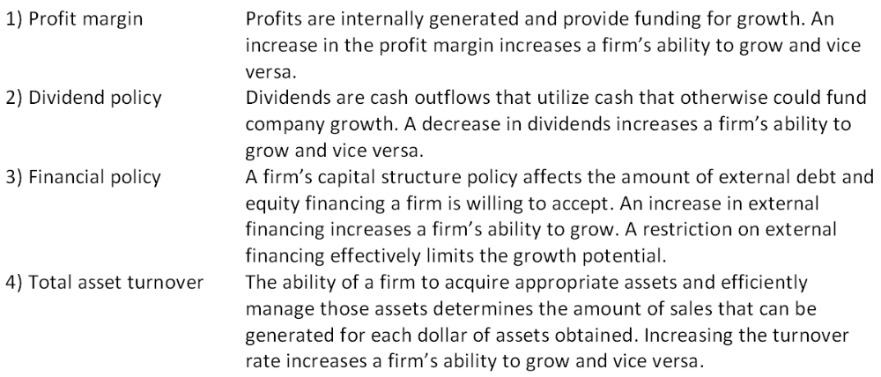
Feedback: Refer to section 4.4

AACSB: Reflective thinking
Difficulty: Intermediate
Learning Objective: 4-3
Section: 4.4
Topic: Determinants of growth
83. A) What are the assumptions that underlie the internal growth rate and B) what are the implications of this rate?
The basic assumptions are: Costs and net working capital increase proportionately with sales. Fixed assets also increase proportionately with sales once production reaches full capacity. The dividend payout ratio is constant. No additional external financing of any kind is permissible.
The implication is that firms are limited to a rate of growth equal to the internal growth rate so long as external financing remains limited at its current level. In other words, the internal growth rate is the maximum rate of growth a firm can achieve based on internally generated funds.
Feedback: Refer to section 4.4

AACSB: Reflective thinking
Difficulty: Intermediate
Learning Objective: 4-3
Section: 4.4
Topic: Internal growth rate
84. Nelson's Landscaping Services just completed a pro forma statement using the percentage of sales approach. The pro forma has a projected external financing need of -$5,500. What are the firm's options in this case?
With a negative external financing need, the firm has a surplus of funds that it can use to reduce current liabilities, reduce long-term debt, buy back common stock, or increase dividends. If acceptable opportunities exist, the firm might also use the extra funds to purchase fixed assets thereby increasing its maximum capacity level, should that need be anticipated.
Feedback: Refer to section 4.3

AACSB: Reflective thinking
Difficulty: Intermediate
Learning Objective: 4-2
Section: 4.3
Topic: External financing need
85. Smith & Daughters is getting ready to compile pro forma statements for the next few years. How can the managers establish a reasonable range of growth rates that they should consider during this planning process?
The internal growth rate establishes the minimum desired rate of growth while the sustainable growth rate identifies the maximum supportable level of growth. These growth rates effectively determine the range of rates than managers should consider.
Feedback: Refer to section 4.4

AACSB: Reflective thinking
Difficulty: Intermediate
Learning Objective: 4-3
Section: 4.4
Topic: Growth rates

Multiple Choice Questions
86. The most recent financial statements for Watchtower, Inc. are shown here (assuming no income taxes):
Assets and costs are proportional to sales. Debt and equity are not. No dividends are paid. Next year's sales are projected to be $5,002. What is the amount of the external financing need?
A. $197
B. $203
C. $211
D. $218
E. $223
Sales increase = ($5,002 - $4,100)/$4,100 = 0.22
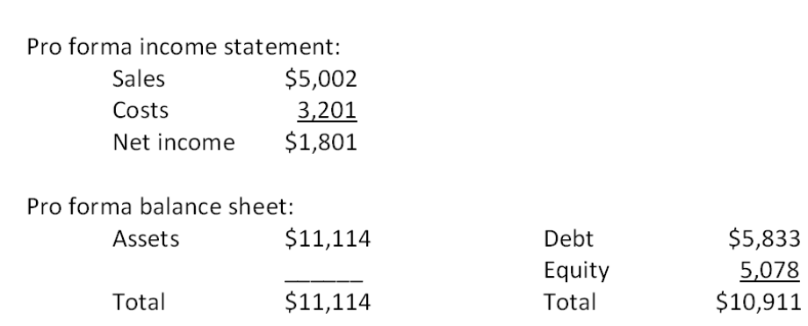
External financing need = $11,114 - $10,911 = $203

AACSB: Analytic
Difficulty: Basic
EOC #: 4-3
Learning Objective: 4-2
Section: 4.3
Topic: External financing need
87. The most recent financial statements for Last in Line, Inc. are shown here:
Assets and costs are proportional to sales. Debt and equity are not. A dividend of $992 was paid, and the company wishes to maintain a constant payout ratio. Next year's sales are projected to be $21,830. What is the amount of the external financing need?
A. $12,711
B. $13,333
C. $13,556
D. $13,809
E. $14,357
Sales increase = ($21,830 - $18,500)/$18,500 = 0.18
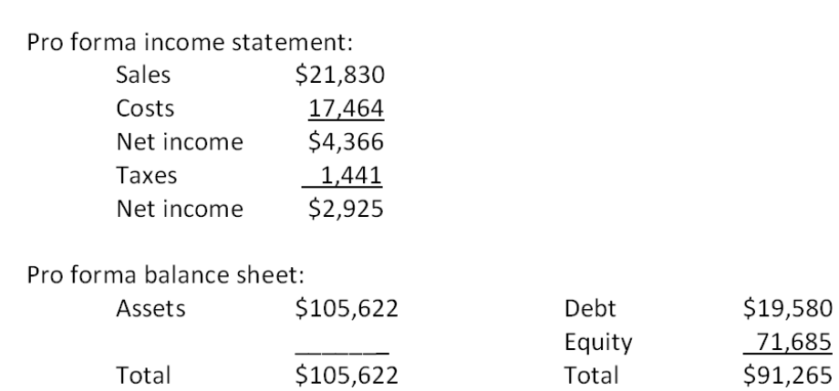
External financing need = $105,622 - $91,265 = $14,357

AACSB: Analytic
Difficulty: Basic
EOC #: 4-4
Learning Objective: 4-2
Section: 4.3
Topic: External financing need
88. The most recent financial statements for 7 Seas, Inc. are shown here:
Assets, costs, and current liabilities are proportional to sales. Long-term debt and equity are not. The company maintains a constant 50 percent dividend payout ratio. Like every other firm in its industry, next year's sales are projected to increase by exactly 16 percent. What is the external financing need?
A. $1,241.76
B. $1,411.16
C. $1,583.09
D. $2,211.87
E. $2,349.98
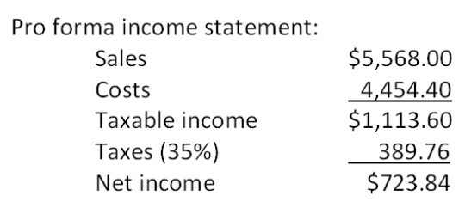
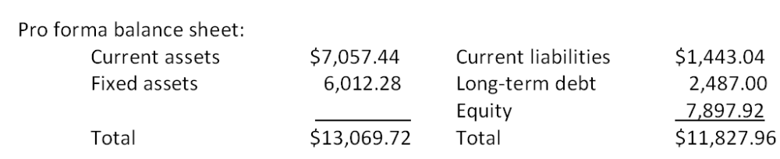
External financing need = $13,069.72 - $11,827.96 = $1,241.76

AACSB: Analytic
Difficulty: Basic
EOC #: 4-5
Learning Objective: 4-2
Section: 4.3
Topic: External financing need
89. The most recent financial statements for Benatar Co. are shown here:
Assets and costs are proportional to sales. Debt and equity are not. The company maintains a constant 40 percent dividend payout ratio. No external equity financing is possible. What is the internal growth rate?
A. 2.91 percent
B. 3.44 percent
C. 3.87 percent
D. 4.02 percent
E. 4.14 percent
Internal growth rate = [($2,665.26/$42,883) × (1 - 0.40)]/{1 - [($2,665.26/$42,883) × (1 - 0.40)]} = 3.87 percent

AACSB: Analytic
Difficulty: Basic
EOC #: 4-6
Learning Objective: 4-3
Section: 4.4
Topic: Internal growth rate
90. The most recent financial statements for Heng Co. are shown here:
Assets and costs are proportional to sales. The company maintains a constant 40 percent dividend payout ratio and a constant debt-equity ratio. What is the maximum increase in sales that can be sustained next year assuming no new equity is issued?
A. $4,808.12
B. $5,211.17
C. $5,987.48
D. $6,493.74
E. $6,666.67
Return on equity = $13,068/$74,250 = 0.176
Retention ratio = 1 - .40 = .60
Sustainable growth rate = (0.176 × .60)/[1 - (0.176 × .60)] = .118068
Maximum increase in sales = $55,000 × .118068 = $6,493.74

AACSB: Analytic
Difficulty: Basic
EOC #: 4-8
Learning Objective: 4-3
Section: 4.4
Topic: Sustainable growth rate
91. Consider the income statement for Heir Jordan Corporation:
A 22 percent growth rate in sales is projected. What is the pro forma addition to retained earnings assuming all costs vary proportionately with sales?
A. $6,299
B. $7,303
C. $7,890
D. $8,011
E. $8,164
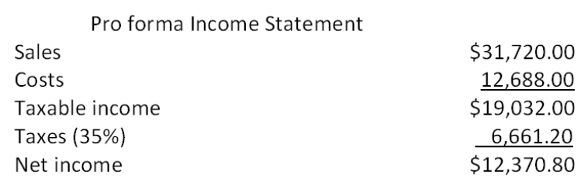
Retention ratio = $6,692/$10,140 = .65996
Pro forma addition to retained earnings = $12,370.80 × .65996 = $8,164

AACSB: Analytic
Difficulty: Basic
EOC #: 4-9
Learning Objective: 4-1
Section: 4.3
Topic: Pro forma statement
92. The Soccer Shoppe has a 7 percent return on assets and a 25 percent payout ratio. What is its internal growth rate?
A. 3.72 percent
B. 4.08 percent
C. 4.49 percent
D. 5.23 percent
E. 5.54 percent
Retention ratio = 1 - 0.25 = 0.75
Internal growth rate = (0.07 × 0.75)/[1 - (0.07 × 0.75)] = 5.54 percent

AACSB: Analytic
Difficulty: Basic
EOC #: 4-12
Learning Objective: 4-3
Section: 4.4
Topic: Internal growth rate
93. The Parodies Corp. has a 22 percent return on equity and a 23 percent payout ratio. What is its sustainable growth rate?
A. 18.68 percent
B. 19.25 percent
C. 19.49 percent
D. 20.39 percent
E. 22.00 percent
Retention ratio = 1 - 0.23 = 0.77
Sustainable growth rate = (0.22 × 0.77)/[1 - (0.22 × 0.77)] = 20.39 percent

AACSB: Analytic
Difficulty: Basic
EOC #: 4-13
Learning Objective: 4-3
Section: 4.4
Topic: Sustainable growth rate
94. Consider the following information for Kaleb's Kickboxing:
What is the sustainable rate of growth?
A. 13.87 percent
B. 14.29 percent
C. 14.65 percent
D. 15.42 percent
E. 15.58 percent
Return on equity = .088 × (1/0.54) × (1 + 0.60) = 0.2607
Retention ratio = 1 - ($15,810/$31,000) = 0.49
Sustainable growth rate = (.2607 × 0.49)/[1 - (.2607 × 0.49)] = 14.65 percent

AACSB: Analytic
Difficulty: Basic
EOC #: 4-14
Learning Objective: 4-3
Section: 4.4
Topic: Sustainable growth rate
95. What is the sustainable growth rate assuming the following ratios are constant?
A. 10.30 percent
B. 10.53 percent
C. 10.67 percent
D. 10.89 percent
E. 11.01 percent
Return on equity = .08 × 1.46 × 1.20 = 0.14016
Retention ratio = 1 - 0.32 = 0.68
Sustainable growth rate = (.14016 × 0.68)/[1 - (0.14016 × 0.68)] = 10.53 percent

AACSB: Analytic
Difficulty: Basic
EOC #: 4-15
Learning Objective: 4-3
Section: 4.4
Topic: Sustainable growth rate
96. Seaweed Mfg., Inc. is currently operating at only 81 percent of fixed asset capacity. Current sales are $550,000. What is the maximum rate at which sales can grow before any new fixed assets are needed?
A. 14.23 percent
B. 14.47 percent
C. 15.03 percent
D. 22.87 percent
E. 23.46 percent
Full capacity sales = $550,000/0.81 = $679,012
Maximum sales growth = (679,012/$550,000) - 1 = 23.46 percent

AACSB: Analytic
Difficulty: Intermediate
EOC #: 4-16
Learning Objective: 4-1
Section: 4.3
Topic: Sales growth
97. Seaweed Mfg., Inc. is currently operating at only 86 percent of fixed asset capacity. Fixed assets are $387,000. Current sales are $510,000 and are projected to grow to $664,000. What amount must be spent on new fixed assets to support this growth in sales?
A. $0
B. $22,654
C. $46,319
D. $79,408
E. $93,608
Full capacity sales = $510,000/0.86 = $593,023.26
Capital intensity ratio = $387,000/$593,023.26 = 0.652588231
Fixed asset need = ($664,000 × 0.652588231) - $387,000 = $46,319

AACSB: Analytic
Difficulty: Intermediate
EOC #: 4-17
Learning Objective: 4-1
Section: 4.3
Topic: Fixed asset need
98. Fixed Appliance Co. wishes to maintain a growth rate of 8 percent a year, a constant debt-equity ratio of 0.34, and a dividend payout ratio of 52 percent. The ratio of total assets to sales is constant at 1.3. What profit margin must the firm achieve?
A. 13.92 percent
B. 14.46 percent
C. 14.97 percent
D. 15.33 percent
E. 15.74 percent
Retention ratio = 1 - 0.52 = 0.48
Sustainable growth rate = 0.08 = (ROE × 0.48)/[1 - (ROE × 0.48)]; ROE = 0.1543
Return on equity = 0.1543 = PM × (1/1.3) × (1 + 0.34); Profit margin = 14.97 percent

AACSB: Analytic
Difficulty: Intermediate
EOC #: 4-18
Learning Objective: 4-3
Section: 4.4
Topic: Sustainable growth rate
99. A firm wishes to maintain a growth rate of 8 percent and a dividend payout ratio of 62 percent. The ratio of total assets to sales is constant at 1, and the profit margin is 10 percent. What must the debt-equity ratio be if the firm wishes to keep that ratio constant?
A. 0.05
B. 0.40
C. 0.55
D. 0.60
E. 0.95
Retention ratio = 1 - 0.62 = 0.38
Sustainable growth rate = 0.08 = (ROE × 0.38)/[1 - (ROE × 0.38)]; ROE = 0.1949
Return on equity = 0.1949 = 0.10 × (1/1) × (1 + D/E); D/E = 0.95

AACSB: Analytic
Difficulty: Intermediate
EOC #: 4-19
Learning Objective: 4-3
Section: 4.4
Topic: Debt-equity ratio
100. A firm wishes to maintain an internal growth rate of 11 percent and a dividend payout ratio of 24 percent. The current profit margin is 10 percent and the firm uses no external financing sources. What must the total asset turnover rate be?
A. 0.87 times
B. 0.90 times
C. 1.01 times
D. 1.15 times
E. 1.30 times
Retention ratio = 1 - 0.24 = 0.76
Internal growth rate = 0.11 = (ROA × 0.76)/[1 - (ROA × 0.76)]; ROA = 0.1304
Return on assets = 0.1304 = 0.10 × TAT; Total asset turnover = 1.30 times

AACSB: Analytic
Difficulty: Intermediate
EOC #: 4-20
Learning Objective: 4-3
Section: 4.4
Topic: Total asset turnover
101. Based on the following information, what is the sustainable growth rate of Hendrix Guitars, Inc.?
A. 7.68 percent
B. 9.52 percent
C. 11.12 percent
D. 13.49 percent
E. 14.41 percent
Total debt ratio = 0.66 = TD/TA
TA/TD = 1/0.66
1 + TD/TE = 1/0.66
D/E = 1/[(1/0.66) - 1] = 1.941176
Return on equity = 0.056 × 1.76 × (1 + 1.941176) = 0.289882
Retention ratio = 1 - 0.7 = 0.3
Sustainable growth rate = (0.289882 × 0.3)/[1 - (0.289882 × 0.3)] = 9.52 percent

AACSB: Analytic
Difficulty: Intermediate
EOC #: 4-21
Learning Objective: 4-3
Section: 4.4
Topic: Sustainable growth rate
102. Country Comfort, Inc. had equity of $150,000 at the beginning of the year. At the end of the year, the company had total assets of $195,000. During the year, the company sold no new equity. Net income for the year was $72,000 and dividends were $44,640. What is the sustainable growth rate?
A. 15.32 percent
B. 15.79 percent
C. 17.78 percent
D. 18.01 percent
E. 18.24 percent
Ending equity = $150,000 + ($72,000 - $44,640) = $177,360
Return on equity = $72,000/$177,360 = 0.4060
Retention ratio = ($72,000 - $44,640)/$72,000 = 0.38
Sustainable growth rate = (0.4060 × 0.38)/[1 - (0.4060 × 0.38)] = 18.24 percent

AACSB: Analytic
Difficulty: Intermediate
EOC #: 4-23
Learning Objective: 4-3
Section: 4.4
Topic: Sustainable growth rate
103. The most recent financial statements for Moose Tours, Inc. follow. Sales for 2009 are projected to grow by 16 percent. Interest expense will remain constant; the tax rate and dividend payout rate will also remain constant. Costs, other expenses, current assets, and accounts payable increase spontaneously will sales. If the firm is operating at full capacity and no new debt or equity is issued, how much external financing is needed to support the 16 percent growth rate in sales?
A. $-10,246
B. -$8,122
C. -$6,708
D. $2,407
E. $3,309
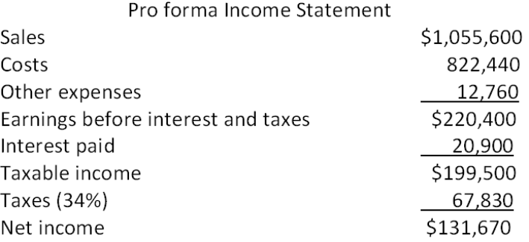
Dividends = ($44,642/$111,606) × $131,670 = $52,668
Addition to retained earnings = $131,670 - $52,668 = $79,002
Ending retained earnings = $268,000 + $79,002 = $347,002
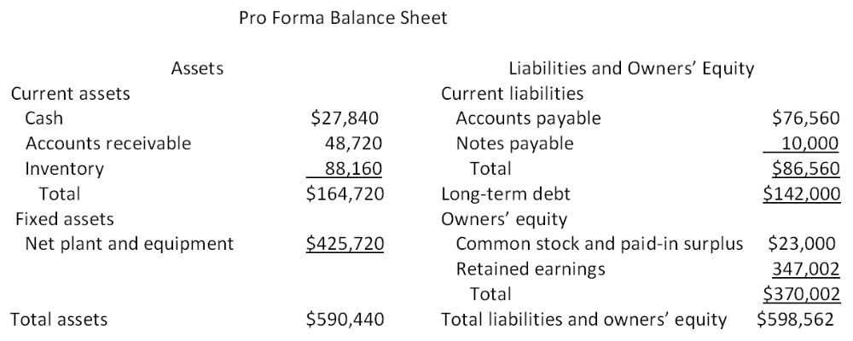
External financing need = $590,440 - $598,562 = -$8,122

AACSB: Analytic
Difficulty: Intermediate
EOC #: 4-25
Learning Objective: 4-2
Section: 4.3
Topic: External financing need

